**A COMPUTERIZED ENVIRONMENTAL MONITORING AND CONTROL SYSTEM USED IN AQUACULTURE**

ABSTRACT:

Aquaculture, as a vital sector in global food production, relies heavily on maintaining optimal environmental conditions for the health and productivity of aquatic organisms. This abstract introduces a state-of-the-art Computerized Environmental Monitoring and Control System designed specifically for aquaculture settings. The system integrates advanced sensor technologies, data analytics, and real-time control mechanisms to ensure precise management of key environmental parameters, such as water quality, temperature, dissolved oxygen, and pH levels.The core components of the system include an array of sensors strategically deployed within the aquaculture facility, continuously collecting data on various environmental factors. These sensors transmit real-time information to a central computerized control unit, which employs sophisticated algorithms to analyze the data and make informed decisions regarding the aquaculture environment. Additionally, the system incorporates a user-friendly interface that allows aquaculturists to monitor conditions and receive alerts, facilitating prompt intervention when necessary.The graphical user interface provides comprehensive visualizations of environmental parameters, enhancing the user's ability to interpret data effectively. Moreover, the system supports remote monitoring and control, enabling aquaculturists to access real-time information and make adjustments from any location. To enhance the understanding of the system's functionality, images and diagrams illustrating the hardware setup, sensor deployment, and user interface are included.

Key features of the Computerized Environmental Monitoring and Control System include:

Real-time Monitoring: Continuous and accurate monitoring of water quality parameters, ensuring a proactive approach to environmental management.

Automated Control: Integration of actuators and control mechanisms that allow for automated adjustments based on the analyzed data, maintaining optimal conditions for aquaculture.

Data Analytics: Implementation of advanced data analytics algorithms for trend analysis, anomaly detection, and predictive modeling, aiding in decision-making and resource optimization.

User-Friendly Interface: An intuitive graphical user interface that provides visual representations of environmental data and allows for easy system interaction.

Remote Accessibility: Capability for remote monitoring and control through web-based applications, enhancing accessibility and enabling timely responses to changing conditions.

This Computerized Environmental Monitoring and Control System represents a significant advancement in the aquaculture industry, offering a reliable and efficient solution for managing and optimizing environmental conditions. The integration of images and diagrams serves to enhance the understanding and appreciation of the system's design and functionality

INTRODUCTION:

Aquaculture, also known as fish farming or aqua farming, is a process of cultivating aquatic animals under specific conditions.

It is cultivating of aquatic organism such as fish, shellfish, salmon, trout, oysters, shrimp and aquatic plants such as seaweed, lotus and microalgae. This is carried out in places like ponds, shorelines, rivers, tanks. Large amount of money can be earned by exporting huge number of aquatic animals mainly fishes in this way it contributes to economic development. The main purpose of aquaculture is to produce seafood and products for human population. The other benefits of aquaculture are it is a great source of protein, also alternative fuel source (for example algae fuel is a cleaner and farmable source of energy) and it increases job opportunities as new machines are introduced.

Aquaculture is classified into 3 categories based on water source:

1. Freshwater aquaculture – Growing organisms in fresh water like ponds, lakes and rivers.

2. Brackish water aquaculture – Growing organisms in brackish water (mix of fresh water and salt water).

3. Mari culture – Growing of organisms in saltwater such as oceans, seas and shallow bays.

Only 13% (10.2 million tons) of water that is available on earth is used for aqua culture. Total production of aquaculture consists of 87.5 million tones where it’s mostly used for human consumption. The graph of aquaculture has drastically increased over the years from 1992-2020 there is no negative slope. It consists of not only fishes but other aquatic animals and plants.

As there is exponential growth in population, new problem raised i.e., water population. Because of this population the quality of water is affected. The most water quality factors are pH, Dissolved Oxygen, Alkalinity, Hardness etc. we need to manually collect samples to find the value of factors which is a tedious task. So we introduced a new methodology to decrease our work of collecting samples

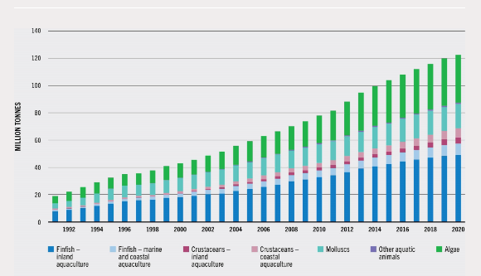

**FIG-1**

In aquaculture, water quality is the most influential and decisive factor affecting production and product quality. If there is poor water quality then it affects both the fishes and the farmer in terms of yields. Aquaculture needs regular maintenance to increase yields. This can be supported from IoT. All the advancements in the technology have a great impact on human. The Internet of Things, also known as the IoT, is a technology that's rapidly growing, and its applications are expanding in diversity. Aquaculture systems built on the AIoT might simultaneously monitor the water quality. The information gathered from such an AIoT system can allow more precise and intelligent aquaculture through the application of sensors and feed data.

As a result, there will be labor savings, stable water quality, energy savings, and precise feeding. We are supervising the object detecting camera and water parameters like pH, turbidity, dissolved oxygen and temperature in real time and development of IoT based system linked with mobile application in which user can monitor this essential water parameter conditions in the fish environment. Standard values for the water parameters are pre-programmed in the processor to test whether the data acquired satisfy the desired value. When the range isn’t met, alert message is sent to user. The acquired sensor data is sent to the smart phone through Bluetooth electronics mobile app and displayed in mobile application.

This aquaculture monitoring helps us with the early detection of water quality, we can practice feeding methods, disease outbreaks, oxygen depletion. It helps us to identify the risks in the system. These technological advancements i.e sensors, ability to monitor the data in mobiles and to have the access anywhere and anytime help the farmers to improve the production. To conclude the computerized monitoring of aquaculture environments helps the farmers yield more and also contributes for economic As there is exponential growth in population, new problem raised i.e., water population. Because of this population the quality of water is affected. The most water quality factors are pH, Dissolved Oxygen, Alkalinity, Hardness etc. we need to manually collect samples to find the value of factors which is a tedious task. So we introduced a new methodology to decrease our work of collecting samples.

Methodology:

The proposed Methodology consists of 3 Stages namely

1)Sensing Stage

2)Computing and Controlling Stage

3)Communication Stage In the sensing stage we monitor the aquaculture system with the sensors like turbidity, pH, temperature, and water level.

pH Sensor: When industrial chemical effluents are released into water bodies, the water's pH fluctuates depending on the type of chemical—basic or acidic. The activity of hydrogen ions in water is measured by the pH sensor to determine the pH level of the water. Fish can typically survive in a pH range of 6 to 8. When the pH falls below 6, the mixture turns acidic and opens the base valve.The acidity valve will open if the pH level rises above 8, as this will make the water basic.

Temperature sensor: determines the water's temperature. Fish can withstand temperatures between 21°C and 33°C. When the temperature rises above the threshold, the motor starts pumping water.

Turbidity sensor: It calculates how much light is scattered off of suspended particles in the water. The turbidity level of the water increases with the amount of total dissolved solids.

water level sensor: It measures the depth of the water. A motor is triggered to pump water to a certain level if the water level is low.

The signal obtained by these sensors is connected to the Arduino board, which controls and computes a portion of the system. communication stage involves a Wi-Fi module. The motor can be activated remotely to change the water, or the circuit can automatically perform operations such as adding acid/base and feeding the fish based on the messages received.

Data collection: The system uses a number of sensors, including as temperature, pH, and TDS, to gather data in real time.Data validation: By confirming the accuracy of the incoming data, the system eliminates any errors

Data aggregation and filtering: Depending on the needs, the system may average or filter data points to provide a smoother trend for analysis.

The communication stage is a critical element in a computerized aquaculture monitoring system. It's responsible for:

Data Transmission:Sending sensor data from underwater probes (e.g., temperature, pH, dissolved oxygen) to a central processing unit (CPU).

1) Transmitting processed data from the CPU to a user interface (UI) for monitoring.

2) Sending alerts or notifications to farmers or technicians if crucial water parameters go outside of acceptable levels.

Advantages of Good Communication

Rapid Intervention: In order to minimise damage to fish and shrimp, early diagnosis of issues with water quality enables rapid corrective action.

Enhancement of Decision-Making: Farmers are empowered to make well-informed decisions on feeding, aeration, and other management measures by having access to both historical and real-time data.

Remote Monitoring: By enabling remote monitoring, the system can lessen the requirement for continual on-site presence throughout aquaculture operations.

Ammonia sensor:Ammonia (NH3) in general is a colourless gas but in aqua farm it is formed by the remaining feed when gets settled in the bottom of the pond and forms a sludgy black soil. As it reacts violently with water and can seriously damages the respiratory system of the shrimp. This gas sensor is installed to warn the amount of an Ammonia being released in the water

Node ESP12E controller:A potent microcontroller with built-in Wi-Fi is the NodeMCU ESP8266. It is widely utilized in Internet of Things (IoT) applications because of its inexpensive cost, user-friendliness, and strong community support. There is, however, a little adjustment in your question. Although the ESP12E is one of the modules available within the ESP8266 family, the ESP8266 microcontroller is often found on the NodeMCU board.   
The significance of the NodeMCU ESP8266 is as follows:  
Wi-Fi access: The NodeMCU's integrated Wi-Fi functionality enables it to connect to both local networks and the internet, which makes it appropriate for Internet of Things applications that need internet access.   
General Purpose Input/Output (GPIO) pins: The NodeMCU has a number of these pins that may be used to interact with different types of sensors, actuators, and other electrical components.

Programming: It is capable to programmed using a variety of tools, such as the Arduino IDE or the Lua programming language. This means that all levels of developers, from novices to specialists, may use it.

Community Support: To assist users in getting started with their projects, a sizable and vibrant community has developed around the NodeMCU ESP12E, offering a wealth of examples, libraries, and tutorials.

Affordability: Due to their low cost, NodeMCU boards are a good choice for hobbyist and prototype applications.

The ESP32-CAM is a small camera module with the ESP32-S chip that besides featuring a camera, also includes Wi-Fi and Bluetooth functionalities. Here are the details about the pins on the ESP32-CAM and their typical purposes:

5V: This is the power supply pin for the module, which typically accepts 5 volts.

GND: Ground pin, used for common ground in the circuit.

IO12: General-purpose input/output pin, often used for boot configuration or interfacing with peripherals.

IO13: General-purpose I/O, can be used for interfacing with sensors or peripherals, and sometimes has an

LED connected to it on the board for indicating status.

IO15: General-purpose I/O, also used for boot configuration and peripheral interfacing.

IO14: General-purpose I/O, can be used for various functions including driving external devices.

IO2: General-purpose I/O, often used as a user-configurable LED indicator or for other simple I/O tasks.

IO4: General-purpose I/O, can be used for interfacing with additional modules or sensors.

VOT: This pin is typically used for voltage output, possibly for an onboard regulator.

VOR: This pin is not standard for ESP32-CAM modules and might be a vendor-specific pin. It could be related to voltage reference or output.

VCC: This is another power supply pin, which might be used for supplying power to the camera or other parts of the module.

IO0: General-purpose I/O, often used for entering the bootloader mode for firmware updates

.

IO16: General-purpose I/O, can be used for various functions, including waking up the module from sleep mode.

3V3: This is the 3.3-volt power supply pin for the module.

Each of these pins can be programmed for various functions depending on the application's requirements. The ESP32-CAM module is versatile and can be used for a wide range of applications, including home automation, surveillance, and IoT projects.

The core components of the system include an array of sensors strategically deployed within the aquaculture facility, continuously collecting data on various environmental factors. These sensors transmit real-time information to a central computerized control unit, which employs sophisticated algorithms to analyze the data and make informed decisions regarding the aquaculture

BLOCK DIAGRAM:

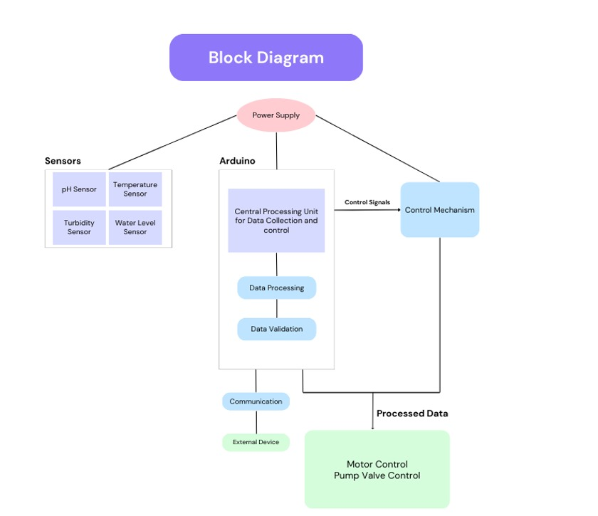

FIG-2

system gathers information on temperature, pH, turbidity, and water level using a variety of sensors. The Arduino, which serves as the system's central processing unit (CPU), receives this data after that. The data is processed and validated by the Arduino to make sure it falls within allowable bounds. Subsequently, the Arduino establishes communication with external devices and transmits control signals to a control mechanism, which may be a pump, valve, heating or cooling system. As a result, the thermostat system can continue to operate at the appropriate pH, turbidity, temperature, or water level. The block diagram consists of five major components. The first section, called "Power Supply," provides electricity to the entire system.The second segment is labelled "Sensors". This section demonstrates that there are four sensors that feed data into the system. The first two sensors are temperature and PH sensors.

These sensors are most likely responsible for sensing the temperature and pH level of the water. The third sensor is a turbidity sensor, which monitors how many suspended particles are in the water. The fourth sensor measures the water level in the system. The CPU uses the information it gets from the sensors to decide how to operate the system. Additionally, the control mechanism receives control signals from the CPU.The section headed "Data Processing and Validation" is the fourth one. This section involves the CPU processing and validating the sensor data. By doing this, the data is verified as valid before being used to operate the system."Communication, Processed Data, External Device, Motor Control, and Pump Valve Control" is the title of the fifth segment. To display the system's present state, the CPU can interface with an external device—possibly a display or a smartphone app. The motor and pump valve are also controlled by the processed data. The pump valve control and motor both manage the water flow of the system

Calibration and sensor redundancy:  
  
Regular Calibration: Sensor readings might drift over time, resulting in erroneous data. A routine calibration regimen assures sensor accuracy and consistent system performance. This might include employing standard solutions or reference sensors for frequent calibration checks.  
Sensor Redundancy for Critical Parameters: For critical parameters such as pH or temperature, consider using redundant sensors. The system may evaluate data from both sensors and, if there are any

disparities, either indicate possible concerns or depend on the sensor with the most recent legitimate value. This redundancy reduces the likelihood of system failure due to a single sensor problem.  
Power Management and System Reliability  
  
Installing an uninterrupted power supply (UPS) offers backup power in the event of a mains power loss. This guarantees continuous monitoring and avoids Data loss during power outages.  
Solar electricity Integration: For ecologically responsible and cost-effective operation, consider combining solar panels with batteries to provide sustainable electricity. This decreases dependency on the grid and lowers the system's environmental impact.  
Improved User Interface and Data Presentation:  
  
Mobile App Interface: Create a user-friendly mobile app that allows remote monitoring of water quality metrics from anywhere with an internet connection. The application may provide real-time statistics, historical patterns, and alarm messages.  
Data Logging and Export: The system should log sensor data over time so that it may be exported for further analysis in spreadsheet software or data visualization tools. This enables users to detect long-term trends and relationships among several water quality metrics.

By adopting these improvements, the system becomes more resilient and dependable. It is also user-friendly. Regular calibration and sensor redundancy maintain data accuracy, while continuous power and solar power alternatives ensure system availability. A mobile app and data logging features enhance the user experience and enable informed decision-making for effective water quality management.

It then analyzes and verifies the data to verify that it meets acceptable standards. Once verified, the Arduino interfaces with external devices, sending control signals to govern pumps, valves, and heating/cooling systems. This enables the thermostat system to maintain ideal settings for pH, turbidity, temperature, and water level.   
  
A block diagram depicts the system's five major components. The first component, "Power Supply," provides electricity for the complete arrangement. The next section, titled "Sensors," depicts the existence of four sensors that provide data to the system. These include temperature.

These include temperature and pH sensors, which measure water temperature and pH levels, respectively. A turbidity sensor monitors suspended particles in the water, while another sensor measures water levels throughout the system. The CPU then uses this sensor data to make operational choices, ensuring that the system runs efficiently.

The core components of the system include an array of sensors strategically deployed within the aquaculture facility, continuously collecting data on various environmental factors. These sensors transmit real-time information to a central computerized control unit, which employs sophisticated algorithms to analyze the data and make informed decisions regarding the aquaculture

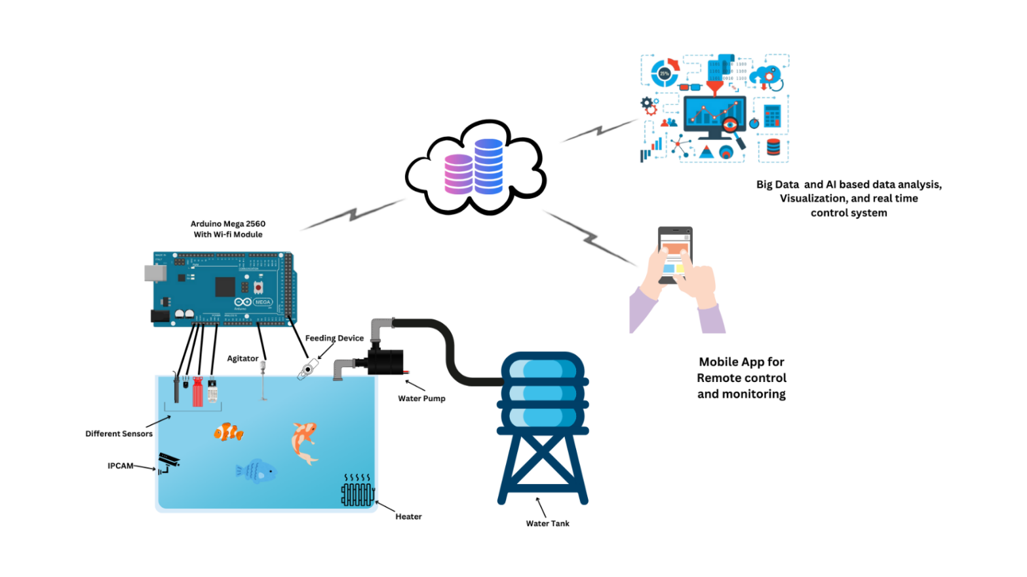

**FIG-3**

A smart water tank with remote monitoring can help maintain optimal water conditions.  
  
This picture shows a smart water tank system that painstakingly monitors and regulates water quality to promote aquatic life. The system uses an Arduino Mega 2560 microcontroller board with a Wi-Fi module for remote access. Several sensors continually gather data on water quality measures, and the processed data may be viewed and examined remotely via a smartphone app.  
  
The Arduino Mega functions as both a central processing unit and communication hub.  
  
The Arduino Mega 2560 is the smart water tank system's central processing unit (CPU). This microcontroller collects sensor data, processes it, and makes operational choices. The Wi-Fi module coupled with the Arduino allows connection with a remote.

server or mobile devices, allowing for real-time water quality monitoring and management modifications.  
Sensory Network: Guardians of Water Quality  
The smart water tank system collects essential water quality data via a network of sensors. These sensors serve as the system's eyes and ears, continually monitoring the aquatic environment. The integrated sensors measure:  
Temperature: A temperature sensor is critical in keeping the water within a safe range for the intended aquatic species.  
pH Level: A pH sensor measures the acidity or alkalinity of the water, which is important for fish health.  
Total Dissolved Solids (TDS): A sensor may be present to measure total dissolved solids, which represent the amount of inorganic and organic compounds dissolved in water.

Water Level: A water level sensor monitors the volume of water in the tank to avoid overflows or pump problems caused by low water levels.

Data validation and maintaining equilibrium:

The raw data from the sensors is sent to the Arduino for processing and confirmation. The Arduino compares sensor values to established acceptable ranges. If a parameter deviates from the desired boundaries, the system can provide alerts or initiate corrective actions to restore balance.

A smartphone app offers a simple interface for remote monitoring of the smart water tank system. This app displays real-time sensor data for water temperature, pH, TDS (if relevant), and water level. The app can also present. Historical data trends allow consumers to spot patterns and potential concerns.  
  
Control Mechanisms: Taking Action to Improve Water Quality.  
  
Based on processed sensor data and user-defined criteria, the Arduino may trigger a variety of control mechanisms to ensure ideal water quality. These mechanisms include the following:  
  
Water Pump: The water pump may be switched on and off to control water flow within the tank.  
Heater and Cooler: If the water temperature drops below the specified level, a heater may be turned on to increase it. In contrast, if the temperature becomes too high, a cooler can be used to lower it.

Feeding Device: The system may incorporate an automated feeding device that delivers fish food using pre-programmed settings or manual control via a mobile app.

Big Data and Real-Time Analysis: Driving Informed Decisions  
  
The smart water tank system uses real-time data and perhaps big data analytics to improve water quality management. By continually gathering and storing sensor data over time, the system may detect trends and patterns. This data may be used to improve feeding schedules, anticipate possible problems, and make educated decisions about water treatment or tank maintenance.  
  
Benefits and Applications: Beyond the Smart Water Tank.  
  
This smart water tank system has several advantages for ensuring healthy and growing aquatic ecosystems. Real-time monitoring, remote access, and automatic control mechanisms provide consistent and optimal water quality. These capabilities are especially useful in aquaculture systems, where accurate water parameters are critical for fish health and output.

The system's fundamental functions may also be extended for purposes other than aquaculture. Similar systems, for example, might be used to monitor aquatic ecosystems in research facilities or to assure the health of animals on show in public aquariums. This smart water tank system's adaptability and customizability make it a great tool for ensuring optimal

The graph you supplied shows the values of the water temperature in an aquaculture system over a period of six days. The graph's y-axis is labeled "Water Temperature (°C)" and the x-axis is labeled "Day-1" through "Day-6."On the graph, the data points for the six days are shown. Day one had a temperature of 26.5 degrees Celsius. On day two, the temperature rose to 27.5 degrees Celsius. On day three, the temperature peaked at 28.8 degrees Celsius. On day four, the temperature dropped to 28.5 degrees Celsius, and on day five, it dropped once more to 27.2 degrees Celsius. Day 6, the final day of record, with a temperature of 26 degrees Celsius.

Overall, the graph indicates that the water's temperature increased somewhat over the first three days before declining during the final three days. Over the course of the six days, there was a 2.8 degree Celsius variation in temperature.

Water bodies called aquaculture systems are used to grow fish, shellfish, and other aquatic creatures. A crucial component of aquaculture is maintaining the right water temperature, which has an impact on the development, well-being, and procreation of the organisms being grown.The ambient air temperature, the quantity of sunshine the system receives, and the water flow rate are some of the variables that might impact the water temperature in an aquaculture system. Operators of aquaculture systems usually employ heaters andchillers to keep the water at the proper temperature. The statistics show a warming tendency for the first three days, followed by a cooling trend for the last three days. The optimal water temperature for particular fish species varies, thus it is critical to keep the temperature within a range that is appropriate for the type of fish being farmed in the aquaculture system.

Aquaculture is the process of breeding, rearing, and harvesting fish, shellfish, algae, and other aquatic creatures in regulated conditions. Aquaculture systems can include land-based tanks, ponds, cages, and open ocean net pens. They are used to produce a variety of fish and shellfish for consumption.

Maintaining the right water temperature is crucial for fish health in aquaculture systems. High temperatures might lead to stress. Fish can contract diseases and possibly die. Low temperatures can limit fish development and reproduction. Aquaculture system operators

This real-time water quality monitoring technology provides considerable benefits to aquaculture. The device contributes to a fish-friendly environment by continually monitoring water quality and allowing for remote modifications. This can result in better fish health, growth rates, and total output yields.  
  
This system's fundamental functions may also be used to a variety of applications other than aquaculture. Similar systems can be used in research facilities to monitor aquatic ecosystems, or in public aquariums to assure the health of displayed species.

Overall, the graph indicates that the water's temperature increased somewhat over the first three days before declining during the final three days. Over the course of the six days, there was a 2.8 degree Celsius variation in temperature. Water bodies called aquaculture systems are used to grow fish, shellfish, and other aquatic creatures. A crucial component of aquaculture is maintaining the right water temperature, which has an impact on the development, well-being, and procreation of the organisms being grown.The ambient air temperature, the quantity of sunshine the system receives, and the water flow rate are some of the variables that might impact the water temperature .

Aquaculture systems, or controlled aquatic habitats, are used to cultivate fish, shellfish, and other species. Maintaining proper water temperature is critical in aquaculture since it directly influences the development, health, and reproductive success of the cultured species. Water temperature may be influenced by a variety of factors, including the surrounding air temperature, the amount of sunshine exposure the system receives, and the velocity at which water flows through the system.

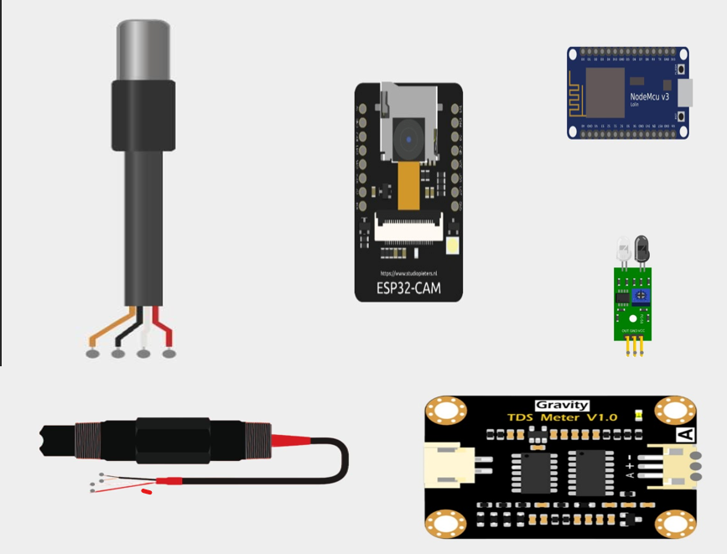

FIG-4

**Fig. 4 |** Overview of the components used in the monitoring the aquaculture system.

This includes TDS(Total dissolved solids) sensor,pH sensor, Obstacle sensor, Temperature sensor, Node MCU and camera. The Tds sensor is used to find the total dissolved solids in the water,the temperature sensor senses the changes in the water temperature levels, the obstacle sensor is used to detect whether any obstacle is there ornot, ensuring a smooth process. The pH sensor detects the change in pH of the water levels. This is used to maintain neutral pH in the water body.The camera is used to detect the movements of the aquatic animals and also to detect any changes in water. A microcontroller unit (MCU) that receives data from each sensor on a regular basis would be attached to the sensors. Each parameter (temperature, pH, etc.) may have precise thresholds defined by programming the MCU. A sensor reading that is below the set threshold may cause the MCU to sound an alert or send out a notice. For additional analysis and visualization, the sensor data can be wirelessly sent to a computer or saved on the MCU. Software may be created to provide sensor values on a dashboard in real time, enabling ongoing aquaculture system health monitoring.

Advantages:  
1) Maintains Optimal Conditions: The system keeps an eye on these crucial variables to make sure the fish are in a stable environment that is conducive to their growth and well-being.

2)Early Alerting Mechanism: Alerts for unusual readings are sent out promptly so that appropriate action may be done in a timely manner and issues are kept from getting worse.  
3)Enhanced Efficiency: By eliminating the need for human checks, automated monitoring saves money on personnel and time.  
4)Data-Driven Management: Over time, patterns may be found and aquaculture procedures can be optimized by using recorded data.  
All things considered, by offering real-time insights into the environment and water quality, a computerized monitoring system that makes use of these sensors may greatly improve the administration of an aquaculture system. This may result in higher output, better overall aquaculture operations, and enhanced fish welfare. translating the data to a more understandable format or making computations on it.

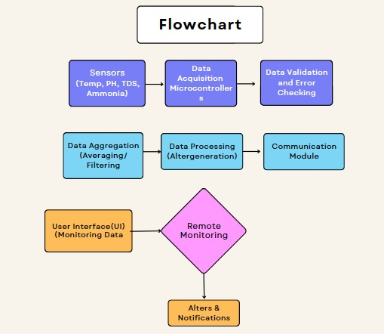

FIG-5

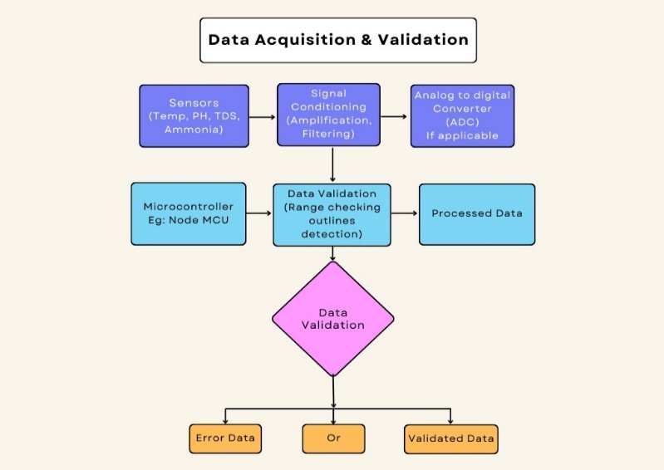

FIG-6

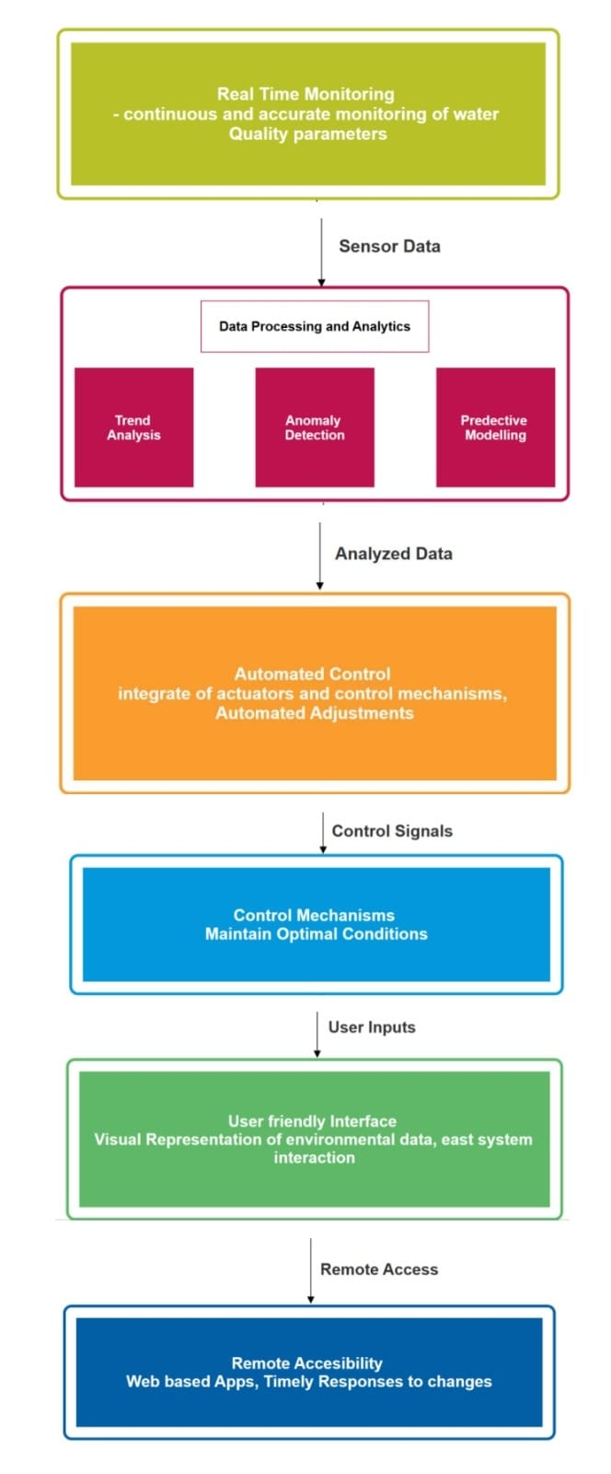

FIG-7

The graphic is organized into five sections: sensor data, data processing and analytics, user inputs, remote access, and web-based apps for rapid reaction.The first portion, called "Sensor Data," has several sensors that collect data on water quality indicators. These characteristics are not defined in the picture, although they may include temperature, pH, chlorine levels,

and dissolved oxygen.The data from the sensors is subsequently directed to the "Data Processing and Analytics" section.The data is filtered and examined to detect patterns and abnormalities. The graphic depicts three possible outcomes ofthis investigation: trend analysis, anomaly identification, and predictive modeling.The "User Inputs" area allows you to manually enter data or

adjust system settings. For example, a user may be able to enter the desired pH level for the water or configure alerts to be warned if specific metrics go outside of acceptable limits.The "Remote Access" area allows you to monitor and operate the system from a remote location. This might be accomplished via a web-based interface or a mobile application. Real-time data might be shown with historical data. Alerts and alerts might also be received remotely.The last part, titled "Web-based Apps, Timely Responses to ," proposes that the system be connected with web-based apps to enable fast responses to changes in water quality.

Changes Real-Time Water Quality Monitoring System: A Flowchart Breakdown.  
  
The flowchart you gave depicts a real-time water quality monitoring system that continually monitors and analyzes numerous water quality indicators to maintain the best circumstances for aquatic life. These systems are critical in aquaculture, a rapidly expanding area of the food business where exact water quality is critical to fish health and productivity.  
  
 Data Acquisition and Preprocessing  
  
The procedure starts with sensors, which are devices placed in the water to assess temperature, pH, total dissolved solids (TDS), and ammonia levels. These sensors continually gather data and transfer it to a microcontroller unit. The microcontroller serves as the system's brain, processing raw sensor data.

Data Validation and Error Check  
  
Data validation and error checking are crucial processes in ensuring that the information acquired by sensors is accurate and reliable. The microcontroller unit uses a variety of ways to verify the data. Range checking is a typical approach that includes determining acceptable minimum and maximum values for each parameter. If a sensor reading falls outside of the specified range, it may be classified as an error or anomaly.Another way for error checking is to compare readings from different sensors that measure the same parameter. Significant differences between sensors can indicate faulty equipment, and the system may provide alarms requiring additional examination.  
  
Data Processing and Analysis  
  
Once approved, the data is processed and analyzed. Data aggregation is the process of merging several data pieces acquired during a specified time period. As an example, To generate a smoother depiction of water quality trends, data processing may include filtering away outliers or inconsequential changes. More sophisticated systems may employ data processing techniques to correct for sensor drift, the phenomenon in which sensor readings diverge from genuine values over time.  
  
Data Visualization & User Interface  
  
The processed data is then utilized to create a user-friendly interface (UI) that displays the information in an understandable and succinct manner. This UI might feature real-time graphs that show changes in water quality measures over time. It might also include color-coded displays to show if parameter values are within the target range or if remedial action is required.  
  
Advanced analytics include trend analysis, anomaly detection, and predictive modeling.  
  
Modern real-time water quality monitoring systems include sophisticated analytics. To gain meaningful insights from the collected data. Trend analysis entails detecting long-term patterns

in water quality parameters. For example, the system may detect a slow increase in water temperature over the course of a week, signaling a possible cooling system malfunction.  
  
Anomaly detection systems seek for abrupt spikes or dips in parameter values that differ considerably from established baselines. These abnormalities might indicate occurrences such as equipment failure or environmental issues, which require prompt response.  
  
Predictive modeling is a strong analytical tool that uses historical data and machine learning to predict future water quality changes. This enables aquaculture system operators to foresee future issues and take proactive steps to ensure ideal conditions.  
  
The real-time water quality monitoring system frequently features a communication module that allows remoteenables aquaculture system operators to monitor water quality from anywhere with an internet connection. This allows for better flexibility and fast reactions to changes in water quality criteria.

Automated Control and User Input

The observed water quality data may be utilized to initiate automated control mechanisms in the aquaculture system. For example, if the temperature increases over a certain level, the system may automatically engage cooling to reduce the temperature.  
  
User interaction through the UI is also important. Operators can specify desired ranges for water quality metrics and build up automatic reactions based on them.  
  
Maintaining optimal conditions.  
  
Real-time water quality monitoring systems are critical for ensuring that aquatic life thrives in aquaculture systems. By consistently accumulating, These technologies, which analyze water quality data, enable aquaculture operators to guarantee fish health and well-being while also increasing output yields.employ a range of technologies to regulate water temperature, including as heaters, coolers, and insulation.

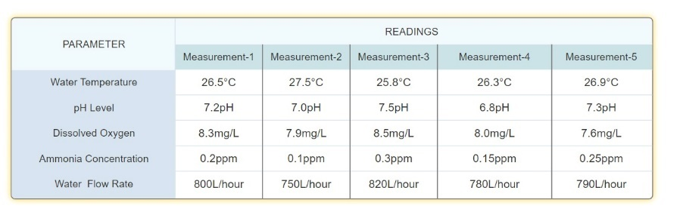

FIG-8

Unlocking the Secrets of the Graph: A Deep Dive into Aquaculture Water Temperature.  
The graph you supplied provides insight into the dynamic world of aquaculture water temperature. Deciphering its patterns and comprehending the driving elements will provide us with vital insights into developing ideal circumstances for thriving aquatic life.  
  
Temperature Fluctuations: A Story of Six Days  
  
The graph shows the temperature flux inside an aquaculture system during a six-day period. We see an initial spike in temperature for the first three days, followed by a gradual decrease throughout the remaining days. The overall temperature fluctuation throughout this time period is 2.8 degrees Celsius. This fluctuation emphasizes the need of monitoring and perhaps controlling water temperature in aquaculture systems, as even seemingly tiny differences can effect the health of the grown organisms.  
  
Aquaculture 101: The Importance of Water Temperature  
  
Aquaculture systems are essentially controlled aquatic habitats used to cultivate fish, shellfish, and other aquatic species. These systems, which range from tiny tanks to expansive ponds, provide a means to produce seafood in a sustainable and regulated manner. Maintaining proper water temperature is critical in these systems. Temperature influences several physiological processes in aquatic life, directly impacting growth, health, and reproductive success

Warmer water frequently speeds up metabolism and feeding activities in fish and other aquatic species. However, overly high temperatures can cause stress and lower development rates.  
Health:

Water temperature can affect the immune system function of aquatic creatures. This makes them more or less vulnerable to illnesses and parasites. Certain temperature ranges may promote various diseases, and maintaining appropriate temperatures might help prevent illness outbreaks.

Reproduction:

Many aquatic species require precise temperature conditions to spawn and breed successfully. Deviations from these ideal limits might result in lower reproductive output or even complete reproductive failure.  
Understanding the Symphony of Factors That Influence Water TemperatureSeveral variables influence the temperature changes seen in aquaculture systems. Here's a deeper look at some of the main players:  
Ambient Air Temperature: The surrounding air temperature has a significant impact on water temperature. On warmer days, the water absorbs heat from the surrounding air, causing the water temperature to rise. In contrast, cooler air temperatures will lead The water releases heat into the surrounding surroundings.  
Solar Radiation:

The quantity of sunlight that the aquaculture system receives is very important. Direct sunlight works as a heat source, increasing the water temperature. The amount of solar energy that enters the water is influenced by a variety of factors, including the duration of daylight hours, cloud cover, and aquaculture system location.  
Water Flow Rate:

The movement of water inside an aquaculture system can assist manage temperature. Proper water flow can help avoid thermal stratification, which occurs when warmer water gathers near the surface and colder water settles at the bottom. Adequate circulation helps to transfer heat more evenly throughout the system.

Maintaining Ideal Temperatures: Strategies for Success  
Given the crucial function of water temperature in aquaculture, many solutions might be appliedTo maintain ideal conditions:The first step is to pick fish or shellfish species that grow in a specified temperature range. This guarantees that the chosen temperature management solutions meet the biological requirements of the cultured organisms.  
Site Selection and Design: The location and design of the aquaculture system have a considerable influence on water temperature. During the planning stages, consider pond depth, shade from trees or structures, and water flow patterns.  
Temperature Monitoring and Control System: Implementing real-time water temperature monitoring systems enables the early detection of changes. Control devices such as heaters, coolers, or aeration systems can be used to manage and maintain water temperature within a certain range.  
Data Analysis and Future Considerations.  
The graph we examined shows a snapshot of water temperature fluctuations in an aquaculture system. To have a more full picture, examine other data points such as:  
Specific Species Being Cultured: Knowing which species are being farmed in the aquaculture system would enable a more targeted investigation of temperature changes in relation to their optimal growth and breeding needs.  
Data on Ambient Air Temperature and Solar Radiation: Including data on ambient air temperature and solar radiation from the same six-day period would allow for a more complete correlation study. This might assist determine the relative contribution of each cause to the observed variations in water temperature.By integrating this new data and utilizing techniques like statistics Through study, we may acquire a better understanding of the elements that influence water temperature in this particular aquaculture system. Such observations might influence future plans for enhancing temperature control methods and contributing to the overall Solar energy has a considerable impact on water temperature. Direct sunlight warms water bodies, increasing their temperature. The amount of solar radiation received by water is determined by factors such as cloud cover, daylight length, and aquaculture system location. Managing solar exposure by shade or placement can aid in the regulation of water temperature.

The depth and amount of water in aquaculture systems influence temperature regulation. Deeper water bodies have more constant temperatures than shallow ones, as they are less impacted by external temperature variations. Larger water quantities give thermal inertia, which helps to buffer temperature swings. Water velocity and circulation in aquaculture systems impact temperature distribution. Adequate water flow distributes heat uniformly across the system, reducing temperature stratification. Proper circulation also guarantees oxygenation and nutrient dispersion, which improves overall aquatic health. Water temperature is influenced by a variety of environmental conditions, including wind exposure and geographical position. Wind can produce evaporative cooling, resulting in temperature reductions, whilst physical factors such as proximity to mountains or bodies of water can impact microclimates and temperature patterns.

CONCLUSION:

The system uses a network of sensors to collect critical water quality data, such as temperature, pH, turbidity, and water level.An Arduino unit receives sensor data, evaluates it, and sends control signals to maintain ideal water conditions via pumps, valves, heaters, and coolers.A user-friendly interface enables remote monitoring and control via cellphones or web apps.Advanced features such as data logging, trend analysis, and anomaly detection enable more informed decisions for better water quality management.Overall, this real-time water quality monitoring system marks a substantial improvement in aquaculture. By maintaining regular and ideal water conditions, the system helps to increase fish health, growth rates, and total output yield. The system's versatility extends beyond aquaculture, providing vital water quality monitoring in Research facilities and public aquariums.  
Furthermore, the publication discusses the significance of water temperature in aquaculture, examining the elements that drive temperature changes and their effects on aquatic life. This understanding is critical for sustaining optimal water conditions and nurturing healthy aquatic habitats.

By taking these aspects into account and using suitable temperature control measures, aquaculture practitioners may establish ideal circumstances for the health, development, and reproduction of aquatic organisms in their systems.

REFFERENCES:

1. Boyd, C.E. (1998). Pond Aquaculture Water Quality Management. Springer Science & Business Media.
2. Tucker, C.S. (1998). Aquaculture and water resource management: global issues. Pond Aquaculture Water Quality Management.
3. Guerrero, R.D., Jr., & Guerrero-Diaz, T.M. (1998). Water quality management in aquaculture: a review. Water, Air, and Soil Pollution, 99(3-4), 291-307.
4. Little, D.C., & Edwards, P. (1998). Sustainable aquaculture: its environmental and social dimension. Pond Aquaculture Water Quality Management.
5. Pillay, T.V.R., & Kutty, M.N. (1998). Aquaculture: Principles and Practices. Pond Aquaculture Water Quality Management.
6. Hargreaves, J.A. (1998). Nitrogen biogeochemistry of aquaculture ponds. Pond Aquaculture Water Quality Management.
7. Avnimelech, Y. (1998). Carbon/nitrogen ratio as a control element in aquaculture systems. Pond Aquaculture Water Quality Management.
8. Chisti, Y. (1998). Immobilized microalgae for removing pollutants: review of immobilization methods and practical aspects of pollutant removal. Pond Aquaculture Water Quality Management.
9. Boyd, C.E., & Massaut, L. (1998). Risks associated with the use of chemicals in pond aquaculture. Pond Aquaculture Water Quality Management.
10. Costa-Pierce, B.A. (1998). Aquaculture ecosystems: adapting agriculture's lessons. Pond Aquaculture Water Quality Management.
11. Seitzinger, S.P., & Garber, J.H. (1998). Nitrogen fixation in freshwater, estuarine, and marine ecosystems. Pond Aquaculture Water Quality Management.
12. Van Huis, A. (1998). Integrated agriculture-aquaculture systems: a resource-based approach
13. Edwards, P. (1998). The environmental impacts of intensive aquaculture. Pond Aquaculture Water Quality Management.
14. Kaushik, S.J. (1998). Influence of pollution on fish physiology and growth. Pond Aquaculture Water Quality Management.
15. Colt, J. (2011). Aquaculture Principles and Practices. Wiley-Blackwell.
16. Stickney, R.R. (2011). Aquaculture: An Introductory Text. Aquaculture Principles and Practices.
17. Hopkins, K.D. (2011). History of Aquaculture. Aquaculture Principles and Practices.
18. Tidwell, J.H., & Allan, G.L. (2011). Fish Nutrition. Aquaculture Principles and Practices.
19. Hargreaves, J.A., & Tucker, C.S. (2011). Biological and Chemical Management of Fish Culture Ponds. Aquaculture Principles and Practices.
20. Guerrero, R.D., Jr., & Guerrero-Diaz, T.M. (2011). Aquaculture and Water Resources Management. Aquaculture Principles and Practices.
21. Boyd, C.E. (2011). Water Quality Management for Pond Aquaculture. Aquaculture Principles and Practices.
22. Avnimelech, Y. (2011). Biofloc Technology in Aquaculture: Beneficial or Detrimental? Aquaculture Principles and Practices.
23. New, M.B., & Tacon, A.G.J. (2011). Aquaculture Certification. Aquaculture Principles and Practices.
24. Costa-Pierce, B.A. (2011). Ecological Aquaculture: The Evolution of the Blue Revolution. Aquaculture Principles and Practices.
25. Buschmann, A.H., & Troell, M. (2011). Seaweed Farming: A New Hope for Sustainable Coastal Development. Aquaculture Principles and Practices.
26. Rothuis, A.J. (2011). Sustainable Aquaculture: The Impact of Aquaculture on

the Environment and Society. Aquaculture Principles and Practices.

1. D'Abramo, L.R., Conroy, G.D., & Taylor, T.L. (2011). Fish Health Management. Aquaculture Principles and Practices.
2. Muir, J.F. (2011). Environmental Risks and Benefits of Aquaculture. Aquaculture Principles and Practices.
3. New, M.B. (2011). Farming Systems and Aquaculture. Aquaculture Principles and Practices.
4. Kestemont, P., & Dabrowski, K. (2005). Use of Environmental Controls in Aquaculture. CRC Press.
5. Dabrowski, K., & Ciereszko, A. (2005). Genetic and Environmental Control of Reproduction in Aquaculture. Use of Environmental Controls in Aquaculture.
6. Amin, M.N., & Noor, M.A. (2005). The Role of Information Technology in Aquaculture Industry. Use of Environmental Controls in Aquaculture.
7. Bierman Jr, V.J. (2005). Biological Control in Aquaculture. Use of Environmental Controls in Aquaculture.
8. Huntington, T.C. (2005). Climate Change and Aquaculture: Potential Impacts, Adaptation Strategies, and Mitigation Measures. Use of Environmental Controls in Aquaculture.
9. Jobling, M. (2005). Environmental Control of Fish Growth: Implications for Aquaculture. Use of Environmental Controls in Aquaculture.
10. Subasinghe, R.P., & Bueno, P. (2005). Environmental Issues Associated with Aquaculture: Potential Solutions. Use of Environmental Controls in Aquaculture.
11. Kirk, D.L., & McNevin, A.A. (2005). Water Quality and Environmental Management in Aquaculture. Use of Environmental Controls in Aquaculture.
12. Ullrich, N.W., & Noakes, D.J. (2005). Environmental Control of Fish Physiology: Implications for Aquaculture. Use of Environmental Controls in Aquaculture.
13. Rothuis, A.J. (2005). Aquaculture and Ecosystem Use of Environmental Controls in Aquaculture.
14. Health: Challenges and Opportunities. Use of Environmental Controls in Aquaculture.
15. Edwards, P., & Boyd, C.E. (2005). Aquaculture Wastewater Treatment and Resource Recovery.
16. Aquaculture: A Holistic Approach to Environmental Management. Use of Environmental Controls
17. Health: Challenges and Opportunities. Use of Environmental Controls in Aquaculture.
18. Edwards, P., & Boyd, C.E. (2005). Aquaculture Wastewater Treatment and Resource Recovery.
19. Blidberg, E., & Zanuttigh, B. (Eds.). (2016). Environmental Design Guidelines for Low Crested Coastal Structures. Springer.
20. Lynett, P., & Wilson, R. (2016). Wave-structure interaction for low crested coastal structures. Environmental Design Guidelines for Low Crested Coastal Structures.
21. Poulos, S.J., & Byrne, S. (2016). Structural design of low crested coastal structures. Environmental Design Guidelines for Low Crested Coastal Structures.
22. Franco, L., & Prieto, G. (2016). Environmental impact assessment for low crested coastal structures. Environmental Design Guidelines for Low Crested Coastal Structures.
23. Allsop, W. (2016). Hydraulic design of low crested coastal structures. Environmental Design Guidelines for Low Crested Coastal Structures.
24. Troch, P., & Verwaest, T. (2016). Sediment transport for low crested coastal structures. Environmental Design Guidelines for Low Crested Coastal Structures.
25. Izquierdo, T., & Aragón, J.L. (2016). Low crested coastal structures and beach morphodynamics. Environmental Design Guidelines for Low Crested Coastal Structures.
26. Trzcinski, J.W., & Riva, R.E.M. (2016). Construction methods for low crested coastal structures. Environmental Design Guidelines for Low Crested Coastal Structures.
27. Sparboom, U., & Kranenburg, C. (2016). Cost-benefit analysis of low crested coastal structures. Environmental Design Guidelines for Low Crested Coastal Structures.
28. Aiello, G., & Vicinanza, D. (2016). Environmental monitoring and maintenance of low crested coastal structures. Environmental Design Guidelines for Low Crested Coastal Structures.
29. Karimanzira, D., & Dickson, M. W. (2014). Environmental Management in Aquaculture: A Technological Approach. LAP Lambert Academic Publishing.
30. Karimanzira, D., & Mhlanga, B. (2014). Environmental impacts of aquaculture: a review of key issues. Environmental Management in Aquaculture.
31. Dickson, M. W., & Karimanzira, D. (2014). Technological solutions for environmental challenges in aquaculture. Environmental Management in Aquaculture.
32. Rahman, M.M., & Karimanzira, D. (2014). Water quality management in aquaculture: challenges and strategies. Environmental Management in Aquaculture.
33. Karimanzira, D., & Moyo, N.A. (2014). Role of integrated aquaculture-agriculture systems in environmental management. Environmental

Management in Aquaculture.

1. Dickson, M.W., & Karimanzira, D. (2014). Environmental risk assessment in aquaculture: principles and practices. Environmental Management in Aquaculture.
2. Karimanzira, D., & Chivandi, E. (2014). Nutrient management in aquaculture: strategies for sustainable production. Environmental Management in Aquaculture.
3. Moyo, N.A., & Karimanzira, D. (2014). Biodiversity conservation in aquaculture systems: approaches and challenges. Environmental Management in Aquaculture.
4. Karimanzira, D., & Chivandi, E. (2014). Environmental regulation and policy frameworks for sustainable aquaculture development. Environmental Management in Aquaculture.
5. Dickson, M.W., & Karimanzira, D. (2014). Role of public-private partnerships in promoting environmentally sustainable aquaculture. Environmental Management in Aquaculture.
6. Timmons, M.B., Ebeling, J.M., Wheaton, F.W., Summerfelt, S.T., & Vinci, B.J. (2002). Recirculating Aquaculture Systems. Cayuga Aqua Ventures.
7. Timmons, M.B., & Ebeling, J.M. (2002). Overview of Recirculating Aquaculture Systems. Recirculating Aquaculture Systems.
8. Wheaton, F.W., & Timmons, M.B. (2002). Design Considerations for Recirculating Aquaculture Systems. Recirculating Aquaculture Systems.
9. Vinci, B.J., & Summerfelt, S.T. (2002). Water Quality Management in Recirculating Aquaculture Systems. Recirculating Aquaculture Systems.
10. Ebeling, J.M., & Timmons, M.B. (2002). Biofiltration and its Application in Recirculating Aquaculture Systems. Recirculating Aquaculture Systems.
11. Timmons, M.B., & Ebeling, J.M. (2002). Effluent Management and Disposal in Recirculating Aquaculture Systems. Recirculating Aquaculture Systems.
12. Summerfelt, S.T., & Vinci, B.J. (2002). Solid Waste Management in Recirculating Aquaculture Systems. Recirculating Aquaculture Systems.
13. Ebeling, J.M., & Timmons, M.B. (2002). Recirculating Aquaculture System Nutrient Management. Recirculating Aquaculture Systems.
14. Wheaton, F.W., & Timmons, M.B. (2002). Energy Management in Recirculating Aquaculture Systems. Recirculating Aquaculture Systems.
15. Vinci, B.J., & Summerfelt, S.T. (2002). Economics of Recirculating Aquaculture Systems. Recirculating Aquaculture Systems.
16. S. Kayalvizhi, Reddy G Koushik, P Vivek Kumar and N VenkataPrasanth, "Cyber Aqua
17. Culture Monitoring System Using Arduino And Raspberry Pi", International Journal of Advanced Research in Electrical Electronics and Instrumentation Engineering, vol. 4, no. 5, pp. 2320- 3765, May 2015.
18. Suresh Babu Chandanapalli, E Sreenivasa Reddy and D Rajya Lakshmi, "Design and Deployment of Aqua Monitoring System Using Wireless Sensor Networks and IAR-Kick", Jouranl of Aquaculture Research &Development, vol. 5, no. 7, pp. 1000283.
19. Daudi S. Simbeye and Shi Feng Yang, "Water Quality Monitoring and Control for Aquaculture Based on Wireless Sensor Networks", JOURNAL OF NETWORKS, vol. 9, no.
20. Changhui Deng, Yanping Gao, Jun Gu and Xinying Miao, "Research on the Growth
21. Model of Aquaculture Organisms Based on Neural Network Expert System", Sixth
22. International Conference on Natural Computation (ICNC 2010), pp. 1812-1815, SEPTEMBER 2010.
23. Wen-Tsai Sung, Jui-Ho Chen, Da-Chiun Huang and Yi-Hao Ju, "MultisensorsRealtime Data Fusion Optimization for IOT Systems", 2014 IEEE International Conference on Systems Man and Cybernetics, October 5-8 2014.
24. Weerasak Cheunta, Nitthita Chirdchoo and Kanittha Saelim, "Efficiency Improvement of an Integrated Giant Freshwater-White Prawn Farming in Thailand Using a Wireless Sensor Network", Research Gate, DECEMBER 2014.
25. Jui-Ho Chen, Wen-Tsai Sung and Guo-Yan Lin, "Automated Monitoring System for the FishFarm Aquaculture Environment", 2015 IEEE International Conference on Systems Man and Cybernetics.
26. Kiran Patil, Sachin Patil, Sachin Patil and Vikas Patil, "Monitoring of Turbidity pH &
27. Temperature of Water Based on GSM", lnternational Journal for Research in Emerging Science and Technology, vol. 2, no. 3, March 2015.
28. M Pradeep Kumar, J Monisha, R Pravenisha, V Praiselin and K Suganya Devi, "The Real
29. Time Monitoring of Water Quality in IoT 42 Environment", International Journal of
30. Innovative Research in ScienceEngineering and Technology, vol. 5, no. 6, March 2016.
31. Akanksha Purohit and UlhasKumar Gokhale, "Real Time Water Quality Measurement System based on GSM", IOSR Journal of Electronics and Commnication Engineering, vol. 9, no. 3, pp. 63-67, May 2014.
32. Sharudin Mohd and Shahrul Zharif, "Intillegent Aquafarm System via SMS".
33. Sheetal Israni, Harshal Meharkure and Parag Yelore, "Application of IoT based System for Advance Agriculture in India", lnternational Journal of Innovative research in Computer and Communication Engineering, vol. 3, no. 11, November 2015.
34. Nikesh Gondchawar and R. S. Kawitkar, "IoT based smart Agriculture", International Journal of advanced research in Computer and Communication Engineering, vol. 5, no. 6, June 2016.
35. P. P. Kr, D. Chatterjee, M. Ghosh and J. Ganguly, "Agricultural problems in India requiring solution through agricultural information systems: Problems and prospects in developing countries", Int. J. Inf. Sci. Comput., vol. 2, no. 1, pp. 33-40, 2015.
36. T. Shah, A. D. Roy, A. S. Qureshi and J. Wang, "Sustaining Asia’s groundwater boom:
37. An overview of issues and evidence", Natural Resour. Forum, vol. 27, no. 2, pp. 130-141, 2003.
38. V. Saiz-Rubio and F. Rovira-Más, "From smart farming towards agriculture 5.0: A review on crop data management", Agronomy, vol. 10, no. 2, pp. 207, Feb. 2020.
39. G. Gao, K. Xiao and M. Chen, "An intelligent IoT- based control and traceability system to forecast and maintain water quality in freshwater fish farms", Comput. Electron. Agricult., vol. 166, Nov. 2019.
40. J. J. Dabrowski, A. Rahman and A. George, "Prediction of dissolved oxygen from pH and water temperature in aquaculture prawn ponds", Proc. Australas. Joint Conf. Artif. Intell. Workshops, pp. 2-6, Dec. 2018.
41. J.-H. Chen, W.-T. Sung and G.-Y. Lin, "Automated monitoring system for the fish farm aquaculture environment", Proc. IEEE Int. Conf. Syst. Man Cybern., pp. 1161-1166, Oct,N. Mahfuz and S. M. Al-Mayeed, "Smart monitoring and controlling system for aquaculture of Bangladesh to enhance robust operation", Proc. IEEE Region 10 Symp.
42. ADS111x Ultra-Small Low-Power I2C-Compatible 860-SPS 16-Bit ADCs
43. Reference Oscillator and Programmable Comparator ADS111x Ultra-Small Low-Power I2CCompatible, Dallas, TX, USA, 2019.
44. C. Encinas, E. Ruiz, J. Cortez and A. Espinoza, "Design and implementation of a distributed IoT system for the monitoring of water quality in aquaculture", Proc. Wireless Telecommun. Symp. (WTS), pp. 1-7, Apr. 2017.
45. W. Vernandhes, N. S. Salahuddin, A. Kowanda and S. P. Sari, "Smart aquaponic with monitoring and control system based on IoT", Proc. 2nd Int. Conf. Informat. Comput. (ICIC), pp. 1-6, Nov. 2017.
46. D. S. Simbeye, J. Zhao and S. Yang, "Design and deployment of wireless sensor networks for aquaculture monitoring and control based on virtual instruments".
47. Electron. Agriculture., vol. 102, pp. 31-42, Mar. 2014.
48. W. Wurts and R. Durborow, "Interactions of ph carbon dioxide alkalinity and hardness in fish ponds", Southern Regional Aquaculture Center Publication, vol. 464, no. 01, 1992. [26] C. Boyd and T. Hanson, "Dissolved-oxygen concentration in pond aquaculture", Global Aquacult. Advocate, vol. 13, no. 01, pp. 40-41, 2010.
49. [27] T. Imai, K. Arai and T. Kobayashi, "Smart Aquaculture System: A Remote Feeding
50. System with Smartphones," 2019 IEEE 23rd International Symposium on Consumer
51. Technologies (ISCT), Ancona, Italy, 2019, pp. 93-96.
52. K. B. R. Teja, M. Monika, C. Chandravathi and P. Kodali, "Smart Monitoring System ”.
53. Pond Management and Automation in Aquaculture," 2020 International Conference on Communication and Signal Processing (ICCSP), Chennai, India, 2020, pp. 204-208,
54. [29] S. Yamabe, K. Fukae, T. Imai, K. Arai and T. Kobayashi, "Multi-sensor Platform for Smart Aquaculture," 2021 IEEE 10th Global Conference on Consumer Electronics (GCCE), Kyoto, Japan, 2021, pp. 356-357, doi: 10.1109/GCCE53005.2021.9621832. [30] K. P.
55. Rasheed Abdul Haq and V. P. Harigovindan, "Water Quality Prediction for Smart Aquaculture Using Hybrid Deep Learning Models," in IEEE Access, vol. 10, pp. 6007860098, 2022, doi: 10.1109/ACCESS.2022.3180482.
56. N. Mahfuz and S. M. Al-Mayeed, "Smart Monitoring and Controlling System for Aquaculture of Bangladesh to Enhance Robust Operation," 2020 IEEE Region 10 Symposium (TENSYMP), Dhaka, Bangladesh, 2020, pp.1128-1133, doi:
57. W. -C. Hu, L. -B. Chen, B. -K. Huang and H. -M. Lin, "A Computer Vision-Based Intelligent Fish Feeding System Using Deep Learning Techniques for Aquaculture," in IEEE Sensors Journal, vol. 22, no. 7, pp. 7185-7194, 1 April1, 2022, doi:
58. G. Shahana, P. Ezhilarasi and S. RajeshKannan, "Comparison of Mamdani and Sugeno fuzzy based data aggregation models for developing smart aquaculture system," 2022 International Conference on Innovative Computing, Intelligent Communication and Smart Electrical Systems (ICSES), Chennai, India, 2022, pp. 1- 8, doi:
59. T. Adiono, A. M. Toha, S. Pamungkas, N. Sutisna and E. Sumiarsih, "Internet of Things for Marine Aquaculture," 2021 International Symposium on Electronics and Smart Devices (ISESD), Bandung, Indonesia, 2021, pp. 1-5, doi: 10.1109/ISESD53023.2021.9501663. [35] R. W. L. Coutinho and A. Boukerche, "Towards a Novel Architectural Design for IoTBased Smart Marine Aquaculture," in IEEE Internet of Things Magazine, vol. 5, no. 3, pp.
60. Gladju, J., Biju Sam Kamalam, and A. Kanagaraj. "Applications of data mining and machine learning framework in aquaculture and fisheries: A review." Smart Agricultural Technology 2 (2022): 100061.
61. Chuyen, Tran Duc, et al. "Design and manufacture control system for water quality based on IoT technology for aquaculture in the Vietnam." Bulletin of Electrical Engineering and Informatics 12.4 (2023): 1893-1900.
62. Chuyen, T. D., Nguyen, D. D., Cuong, N. C., & Thong, V. V. (2023). Design and manufacture control system for water quality based on IoT technology for aquaculture in the Vietnam. Bulletin of Electrical Engineering and Informatics, 12(4), 1893-1900. [39] Chiu MC, Yan WM, Bhat SA, Huang NF. Development of smart aquaculture farm management system using IoT and AI-based surrogate models. journal of Agriculture and Food Research. 2022 Sep 1;9:100357.
63. Al-Mutairi AW, Al-Aubidy KM. IoT-based smart monitoring and management system for fish farming. Bulletin of Electrical Engineering and Informatics. 2023 Jun 1;12(3):1435-
64. Yadav A, Noori MT, Biswas A, Min B. A concise review on the recent developments in the internet of things (IoT)-based smart aquaculture practices. Reviews in Fisheries Science & Aquaculture. 2023 Jan 2;31(1):103-18.
65. Hu, Wu-Chih, Liang-Bi Chen, Bo-Kai Huang, and Hong-Ming Lin. "A computer visionbased intelligent fish feeding system using deep learning techniques for aquaculture." IEEE Sensors Journal 22, no. 7 (2022): 7185-7194.
66. Zhang H, Liu Y, Gui F, Yang X. A Universal Aquaculture Environmental Anomaly Monitoring System. Sustainability. 2023 Mar 24;15(7):5678.
67. Das BK, Meena DK, Das A, Sahoo AK. Prospects of Smart Aquaculture in Indian Scenario: A New Horizon in the Management of Aquaculture Production Potential. InSmart and Sustainable Food Technologies 2022 May 14 (pp. 59-85). Singapore: Springer Nature Singapore.
68. Islam, Md Monirul, Mohammad Abul Kashem, and Jia Uddin. "An internet of things framework for real-time aquatic environment monitoring using an Arduino and sensors." International Journal of Electrical and Computer Engineering 12, no. 1 (2022): 826.
69. Lu, Hoang-Yang, Chih-Yung Cheng, Shyi-Chyi Cheng, Yu-Hao Cheng, Wen-Chen Lo, Wei-Lin Jiang, Fan-Hua Nan, Shun-Hsyung Chang, and Naomi A. Ubina. "A low-cost AI buoy system for monitoring water quality at offshore aquaculture cages." Sensors 22, no. 11 (2022): 4078.
70. Baculot, Jeffrey R., et al. "Design of a Controlled Aquaculture Environment with Smart Feeding System." 2022 IEEE 14th International Conference on Humanoid, Nanotechnology,
71. Information Technology, Communication and Control, Environment, and Management (HNICEM). IEEE, 2022.
72. Adamo, Greta, and Max Willis. "Technologically mediated practices in sustainability transitions: Environmental monitoring and the ocean data buoy." Technological Forecasting and Social Change 182 (2022): 121841.
73. Jamroen, C., Yonsiri, N., Odthon, T., Wisitthiwong, N., & Janreung, S. (2023). A standalone photovoltaic/battery energy-powered water quality monitoring system based on narrowband internet of things for aquaculture: Design and implementation. Smart Agricultural Technology, 3, 100072.
74. Prapti DR, Mohamed Shariff AR, Che Man H, Ramli NM, Perumal T, Shariff M.
75. Internet of Things (IoT)‐based aquaculture: An overview of IoT application on water quality monitoring. Reviews in Aquaculture. 2022 Mar;14(2):979-92